Bài 1: So sánh kết cục sản và nhi khoa giữa hai nhóm phụ nữ có và không mắc Covid-19

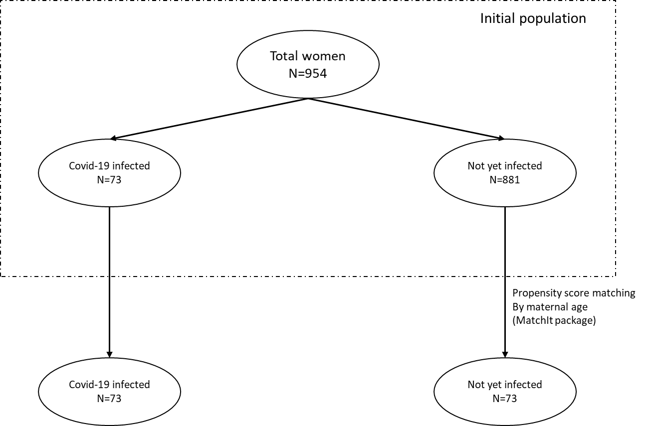

Table 1. Baseline characteristics of pregnant women with or without the Covid-19 infection

|  |  |  |  |
| --- | --- | --- | --- |
|  | Not yet infected by Covid-19 | Infected | p value |
|  | N=73 | N=73 |  |
| Maternal age – years | 29.9±4.2 | 29.9±4.2 | 1 |
| Previous_pregnancies–n(%) |  |  | <0.001 |
| 0 | 32 (43.8%) | 8 (11.0%) |
| 1 | 22 (30.1%) | 30 (41.1%) |
| 2 | 17 (23.3%) | 30 (41.1%) |
| 3 | 2 (2.7%) | 5 (6.8%) |
| Pregnancy type – n (%) |  |  | 0.132 |
| Assisted | 9 (12.3%) | 3 (4.1%) |
| Natural conceived | 64 (87.7%) | 70 (95.9%) |
| Vaccination status – n (%) |  |  | 1 |
| Fully vaccinated | 52 (71.2%) | 53 (72.6%) |
| Only 1 dose | 21 (28.8%) | 20 (27.4%) |
| First vaccine type – n (%) |  |  | 0.869 |
| AstraZeneca | 36 (49.3%) | 38 (52.1%) |  |
| Pfizer BioNTech | 37 (50.7%) | 35 (47.9%) |  |
| Second vaccine type – n (%) |  |  | 0.757 |
| AstraZeneca | 21 (40.4%) | 24 (45.3%) |  |
| Pfizer BioNTech | 31 (59.6%) | 29 (54.7%) |  |
| Gestational age at vaccination – weeks | 31.6±5.1 | 31.5±4.1 | 0.883 |
| Gestational HBP – n (%) | 0 (0.0%) | 0 (0.0%) | - |
| Gestational diabetes – n (%) | 2 (2.7%) | 9 (12.3%) | 0.06 |

Table 2. Pregnancy and neonatal outcomes in pregnant women with or without the Covid-19 infection

|  |  |  |  |  |  |
| --- | --- | --- | --- | --- | --- |
|  | Not yet infected  by Covid-19 | Infected by Covid-19 | RR (95% CI) | Between group difference (95% CI) | p value |
|  | N=73 | N=73 |  |
| Gestational HBP after vaccination – n (%) | 2 (2.7%) | 0 (0.0%) | - | 2.7 [-2.3;7.8] | 1 |
| Gestational diabetes after vaccination – n (%) | 0 (0.0%) | 2 (2.7%) | - | 2.7 [-2.3;7.8] | 0.071 |
| Gestational at birth – weeks | 38.0±2.4 | 38.7±1.2 | - | 0.7 [0.1;1.34] | 0.022 |
| Preterm delivery <28 weeks | 1 (1.4%) | 0 (0.0%) | - | 1.4 [-2.6;5.4] | 1 |
| Preterm delivery <34 weeks | 4 (5.5%) | 0 (0.0%) | - | 5.5 [-1.1;12.1] | 0.12 |
| Preterm delivery <37 weeks | 8 (11.0%) | 5 (6.8%) | 0.63 [0.2;1.8] | 4.2 [-6.5;14.7] | 0.563 |
| Gestational oligohydramnios – n (%) | 1 (1.4%) | 6 (8.2%) | 6.0 [0.7;48.6] | 6.8 [-1.4;15.1] | 0.116 |
| Gestational polyhydramnios – n (%) | 2 (2.7%) | 4 (5.5%) | 2.0 [0.4;10.6] | 2.8 [-5.1;10.5] | 0.681 |
| Maternal ICU events after vaccination – n (%) | 0 (0.0%) | 0 (0.0%) | - | - | - |
| Still birth – n (%) | 0 (0.0%) | 0 (0.0%) | - | - | - |
| Birthweights – grams | 3461.4±433.0 | 3196.6±407.6 | - | 264.8 [-127.2;402.3] | <0.001 |
| Low birthweight – n (%) | 0 (0.0%) | 2 (2.7%) | - | 2.7 [-2.3;7.8] | 0.497 |
| Heavy birthweight – n (%) | 3 (4.2%) | 2 (2.7%) | 0.7 [0.1;3.9] | 1.5 [-5.9;8.6] | 0.681 |
| Birthweight percentile – percent | 90.0 [75.0;90.0] | 50.0 [25.0;75.0] | - | - | <0.001 |
| Lower than 10th percentile birthweight – n (%) | 0 (0.0%) | 1 (1.4%) | - | 1.4 [-2.6;5.4] | 1 |
| Neonatal ICU events – n (%) | 1 (1.4%) | 4 (5.5%) | 4.0 [0.5;34.9] | 4.1 [-3.1;11.3] | 0.366 |
| Neonatal defects – n (%) | 0 (0.0%) | 1 (1.4%) | - | 1.4 [-2.6;5.4] | 1 |

Bài 2: So sánh kết cục sản và nhi khoa theo các mốc chích vaccine

Table 1. Baseline characteristics of pregnant within each group of gestational age (weeks) at vaccination point of time

|  |  |  |  |  |  |
| --- | --- | --- | --- | --- | --- |
|  | First_quartile (<29.43 weeks) | Fourth_quartile (29.43-32.71 weeks) | Second_quartile (32.71 - 35.43 weeks) | Third_quartile (>35.43 weeks) | p.overall |
| Maternal age – years | 31.7±4.2 | 31.3±4.9 | 31.2±4.2 | 31.2±4.5 | 0.51 |
| Previous pregnancies – n (%) |  |  |  |  | <0.001 |
| 0 | 132 (56.2%) | 119 (52.0%) | 94 (40.5%) | 88 (36.5%) |  |
| 1 | 56 (23.8%) | 51 (22.3%) | 67 (28.9%) | 74 (30.7%) |  |
| 2 | 36 (15.3%) | 46 (20.1%) | 58 (25.0%) | 64 (26.6%) |  |
| ≥3 | 11 (4.7%) | 13 (5.6%) | 13 (5.6%) | 15 (6.2%) |  |
| Type of pregnancy – n (%) |  |  |  |  | <0.001 |
| Assisted | 43 (18.3%) | 20 (8.7%) | 15 (6.5%) | 15 (6.2%) |  |
| Natural | 192 (81.7%) | 209 (91.3%) | 217 (93.5%) | 226 (93.8%) |  |
| Vaccination status – n (%) |  |  |  |  | <0.001 |
| Fully vaccinated | 112 (47.7%) | 177 (77.3%) | 176 (75.9%) | 200 (83.0%) |  |
| Only 1 dose | 123 (52.3%) | 52 (22.7%) | 56 (24.1%) | 41 (17.0%) |  |
| First dose vaccine – n (%) |  |  |  |  | 0.088 |
| AstraZeneca | 107 (45.5%) | 93 (40.6%) | 109 (47.0%) | 126 (52.3%) |  |
| Pfizer BioNTech | 128 (54.5%) | 136 (59.4%) | 123 (53.0%) | 115 (47.7%) |  |
| Second dose vaccine – n (%) |  |  |  |  | <0.001 |
| AstraZeneca | 31 (27.7%) | 56 (31.6%) | 74 (42.0%) | 100 (50.0%) |  |
| Pfizer BioNTech | 81 (72.3%) | 121 (68.4%) | 102 (58.0%) | 100 (50.0%) |  |
| Gestational HBP before vaccination – n (%) | 1 (0.4%) | 1 (0.4%) | 0 (0.0%) | 1 (0.4%) | 0.904 |
| Gestational diabetes before vaccination – n (%) | 45 (19.1%) | 11 (4.8%) | 32 (13.8%) | 32 (13.3%) | <0.001 |
| Gestational oligohydramnios – n (%) | 7 (3.0%) | 3 (1.3%) | 8 (3.4%) | 9 (3.8%) | 0.405 |
| Gestational polyhydramnios – n (%) | 6 (2.6%) | 8 (3.5%) | 10 (4.3%) | 13 (5.4%) | 0.434 |

Table 2. Pregnancy and neonatal outcomes in pregnant women within each group of gestational age (weeks) at vaccination point of time

|  |  |  |  |  |  |
| --- | --- | --- | --- | --- | --- |
|  | First_quartile (<29.43 weeks) | Fourth_quartile (29.43-32.71 weeks) | Second_quartile (32.71 - 35.43 weeks) | Third_quartile (>35.43 weeks) | p.overall |
| Maternal ICU events after vaccination – n (%) | 1 (0.4%) | 0 (0.0%) | 1 (0.4%) | 0 (0.0%) | 0.617 |
| Gestational HBP after vaccination – n (%) | 0 (0.0%) | 1 (0.4%) | 1 (0.4%) | 4 (1.7%) | 0.162 |
| Gestational diabetes after vaccination – n (%) | 4 (1.7%) | 0 (0.0%) | 1 (0.4%) | 1 (0.4%) | 0.154 |
| Gestational at birth – weeks | 38.1±2.2 | 38.8±0.8 | 38.5±1.3 | 38.6±1.1 | <0.001 |
| Preterm delivery <28 weeks | 3 (1.3%) | 0 (0.0%) | 0 (0.0%) | 0 (0.0%) | 0.045 |
| Preterm delivery <34 weeks | 11 (4.7%) | 0 (0.0%) | 2 (0.9%) | 1 (0.4%) | <0.001 |
| Preterm delivery <37 weeks | 31 (13.2%) | 3 (1.3%) | 17 (7.3%) | 11 (4.6%) | <0.001 |
| Still birth – n (%) | 2 (0.9%) | 0 (0.0%) | 0 (0.0%) | 1 (0.4%) | 0.525 |
| Birthweights – grams | 3094.7±514.8 | 3184.7±331.3 | 3133.7±391.9 | 3107.7±410.2 | 0.098 |
| Low birthweight – n (%) | 16 (6.9%) | 2 (0.9%) | 7 (3.0%) | 13 (5.4%) | 0.006 |
| Heavy birthweight – n (%) | 4 (1.7%) | 5 (2.2%) | 3 (1.3%) | 4 (1.7%) | 0.899 |
| Birthweight percentile – [mean] percent | 50.9±28.5 | 47.0±26.9 | 47.7±28.2 | 44.0±28.9 | 0.069 |
| Birthweight percentile – [median] percent | 50.0 [25.0;75.0] | 50.0 [25.0;75.0] | 50.0 [25.0;75.0] | 50.0 [25.0;75.0] | 0.059 |
| Lower than 10th percentile birthweight – n (%) | 10 (4.3%) | 7 (3.1%) | 8 (3.4%) | 19 (7.9%) | 0.051 |
| Neonatal ICU events – n (%) | 12 (5.1%) | 7 (3.1%) | 9 (3.9%) | 19 (7.9%) | 0.082 |
| Neonatal defects – n (%) | 2 (0.9%) | 2 (0.9%) | 0 (0.0%) | 4 (1.7%) | 0.285 |
| Maternal infected by Covid-19 – n (%) | 24 (10.2%) | 12 (5.2%) | 19 (8.2%) | 18 (7.5%) | 0.253 |